ACADGILD

**BIG DATA HADOOP & SPARK TRAINING**

**SESSION – 1**

Assignment - **1.1**

**TABLE OF CONTENTS**

* Problem Statement …………………………………………………… 1
* AcadGild VM Installation ……………………………………………. 1

Steps & Output ……………………………………………………. 1

* Starting AcadGild VM’s Daemons ………………..…………….……. 5

Commands & Output ....…………………………………………… 5

**Problem Statement:**

Import AcadGild VM into Oracle Virtual Box and share screenshot of imported AcadGild VM.

**AcadGild VM Installation:**

**Step 1:** Install and Open Oracle Virtual Box

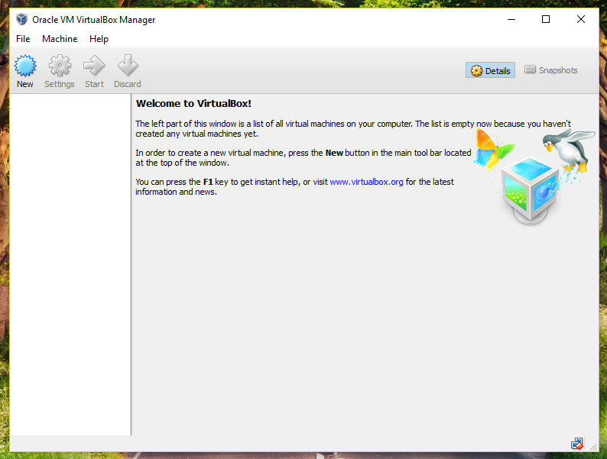

**Step 2:** Import the AcadGild VM into the Virtual Box

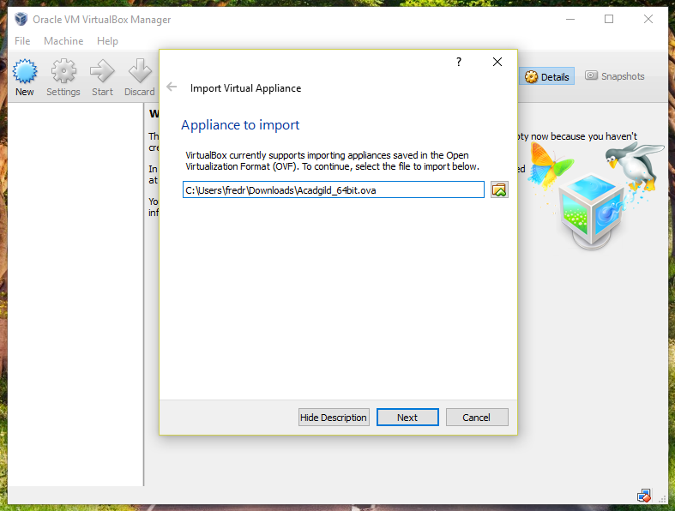

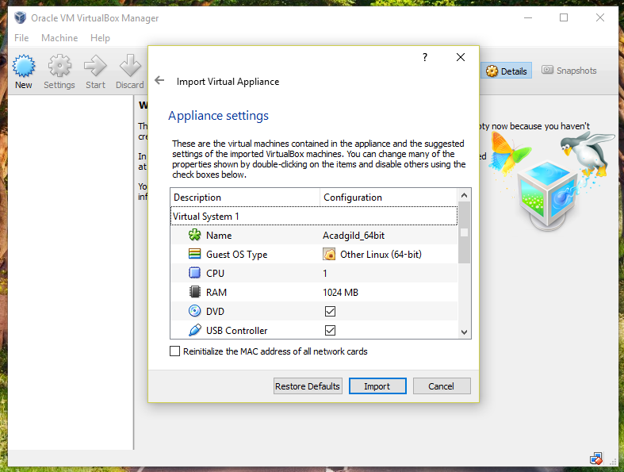

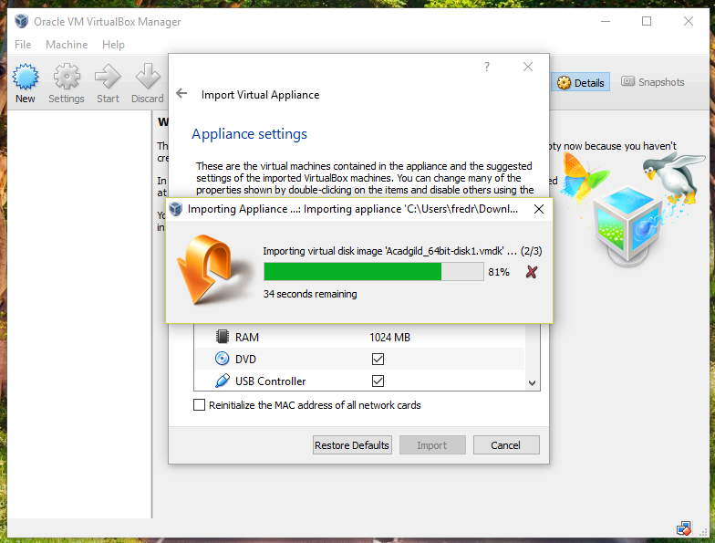

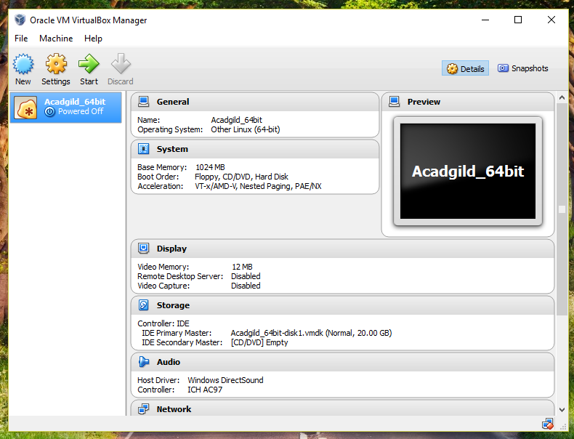

**Step 3:** Run the AcadGild VM



**Step 4:** Login to AcadGild VM

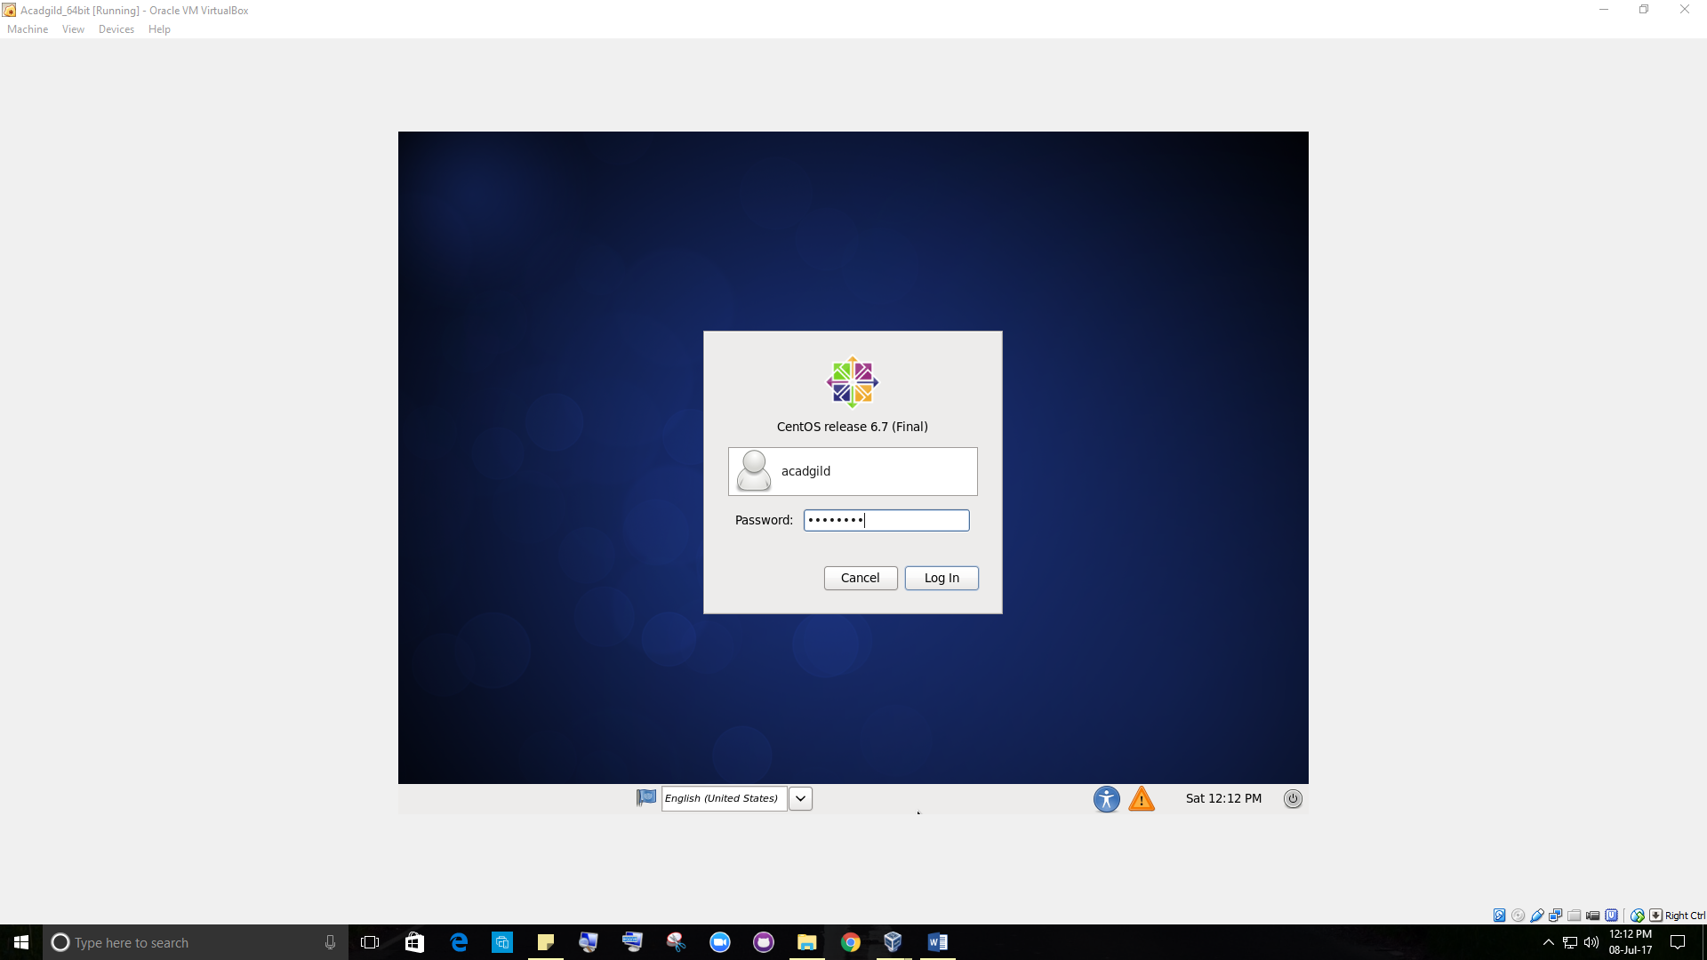

**RESULT:**

Imported and Running AcadGild VM



**Starting AcadGild VM’s Daemons:**

**Command 1:** jps

To check the list of daemons we need to start.

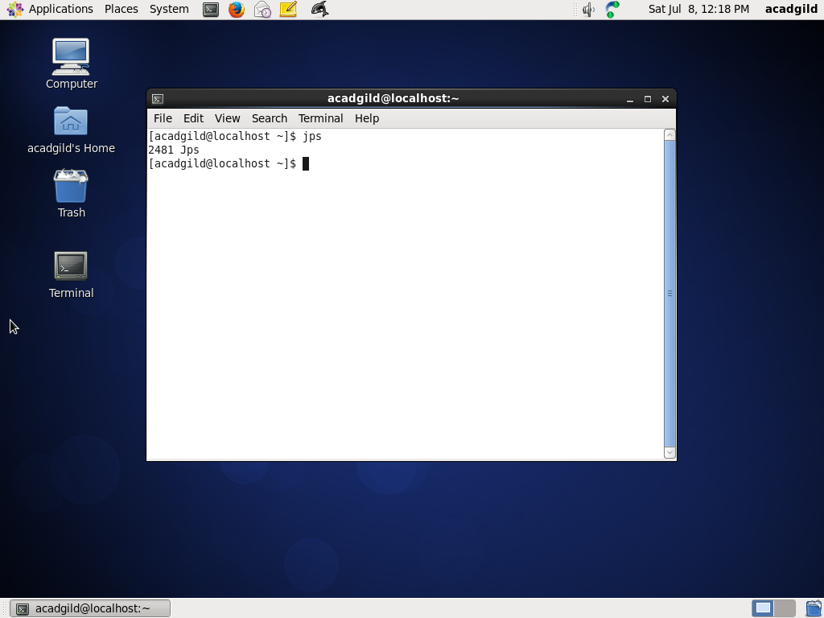

**Command 2:** sudo service sshd start

To start the ssh server. The Service had already started on my machine

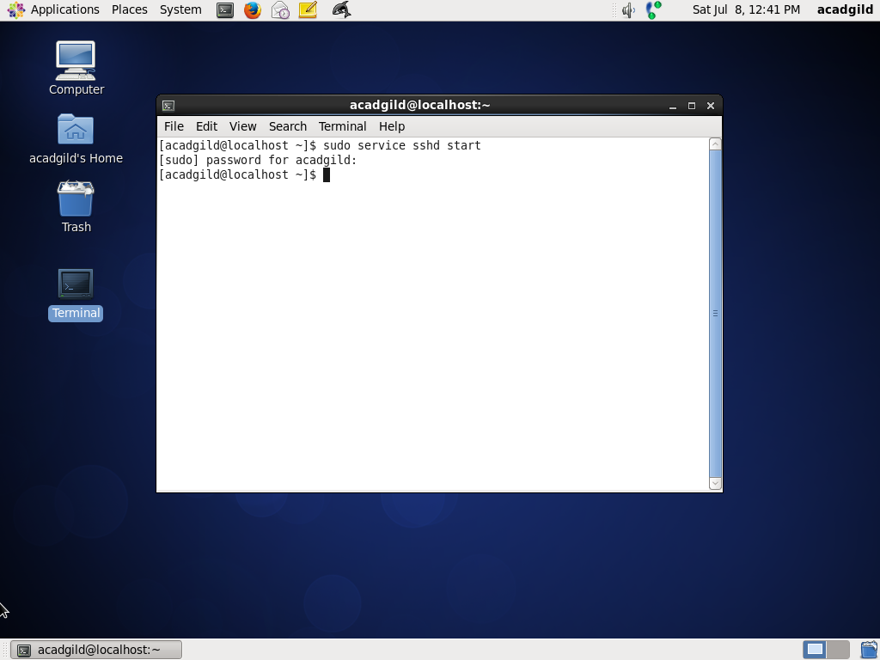

**Command 3:** start-all.sh (To start all daemons)

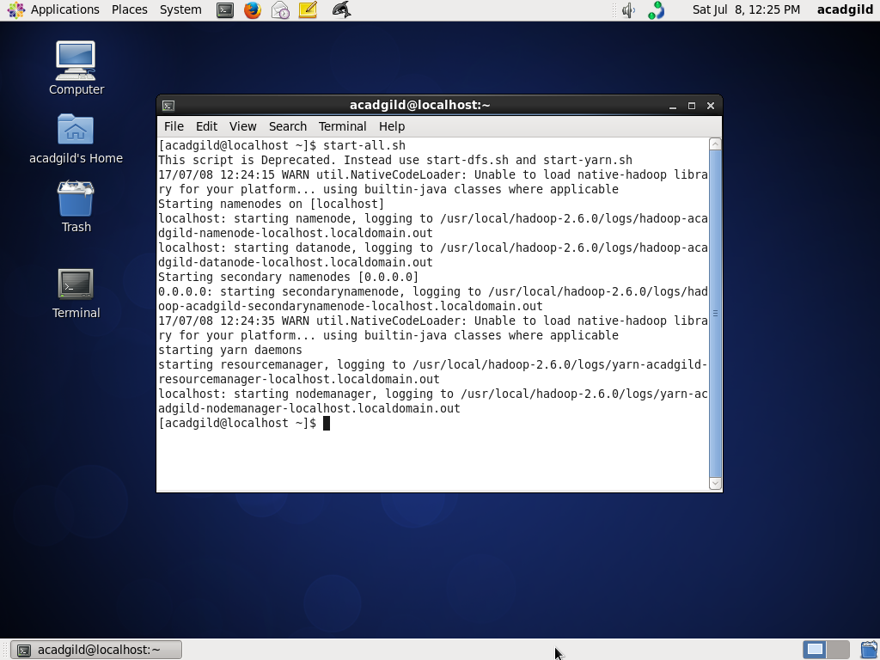

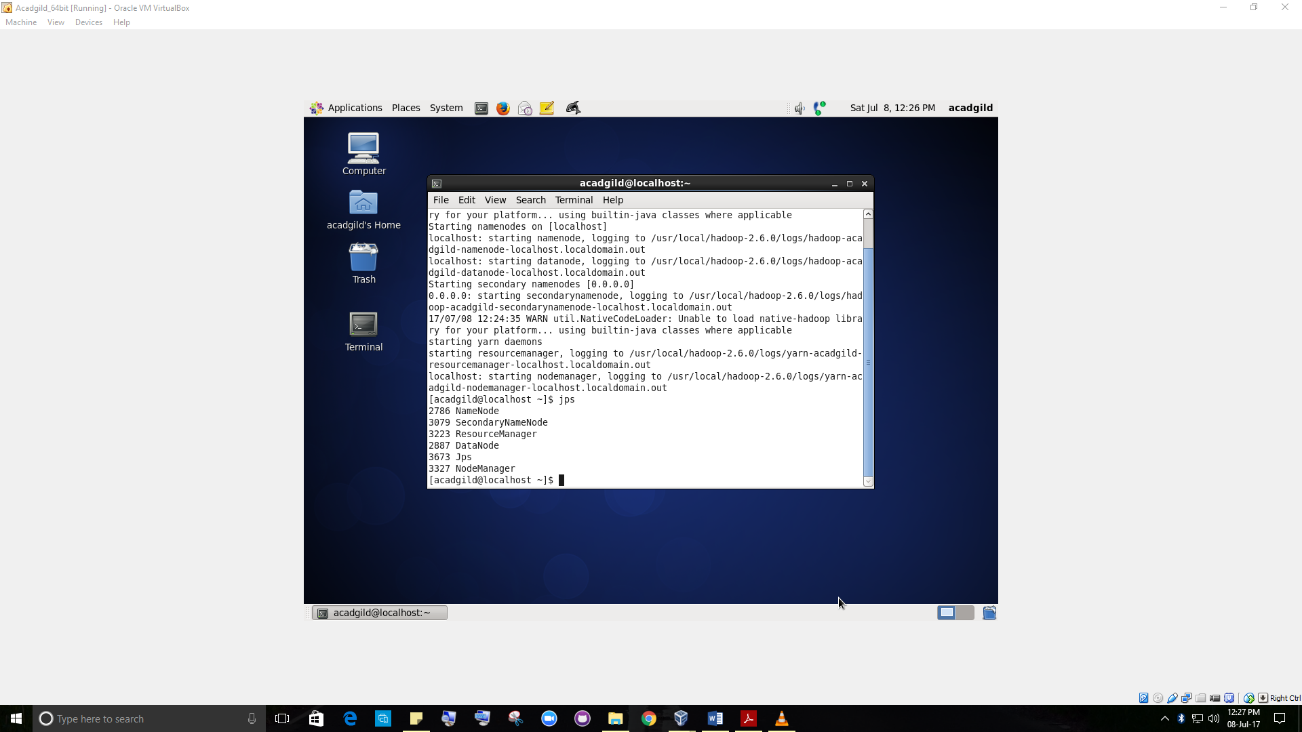

**Command 4:** mr-jobhistory-daemon.sh start historyserver

(To start historyserver.)

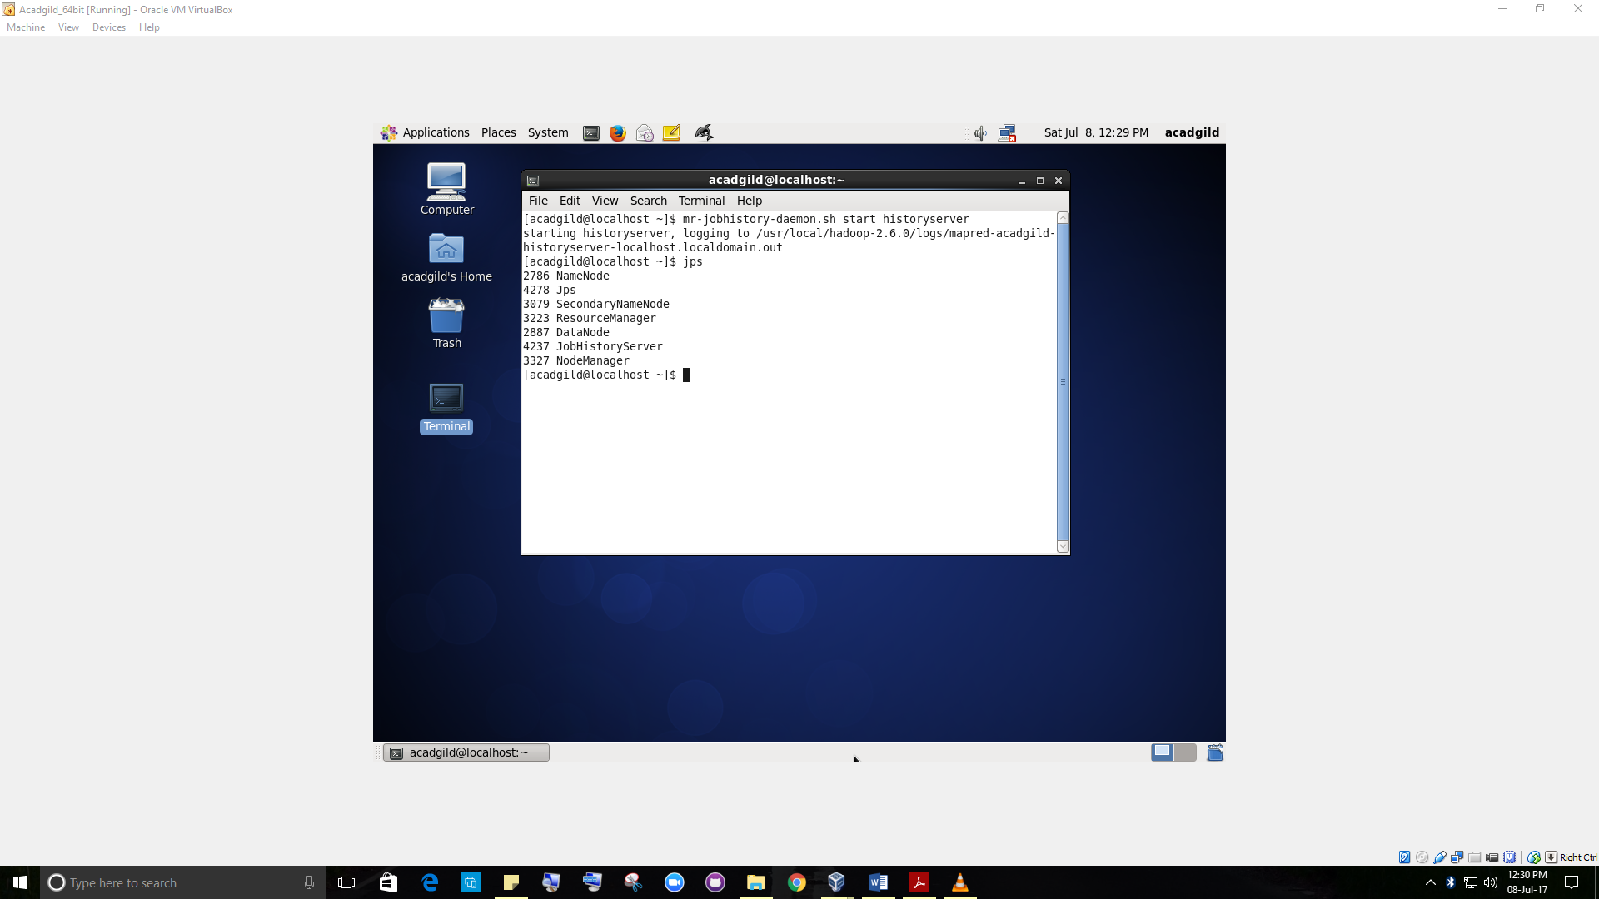

**Command 5:** pig (To start pig in hdfs mode)

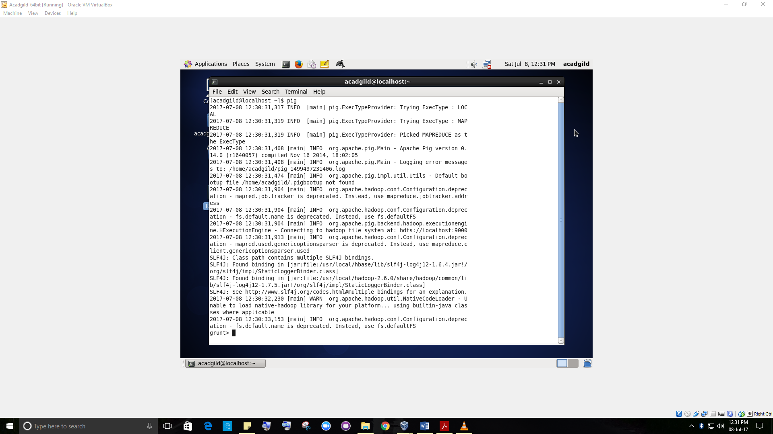

**Command 6:** sudo service mysqld start

To start mysql service (needed for hive)

**Command 7:** hive (To start hive)

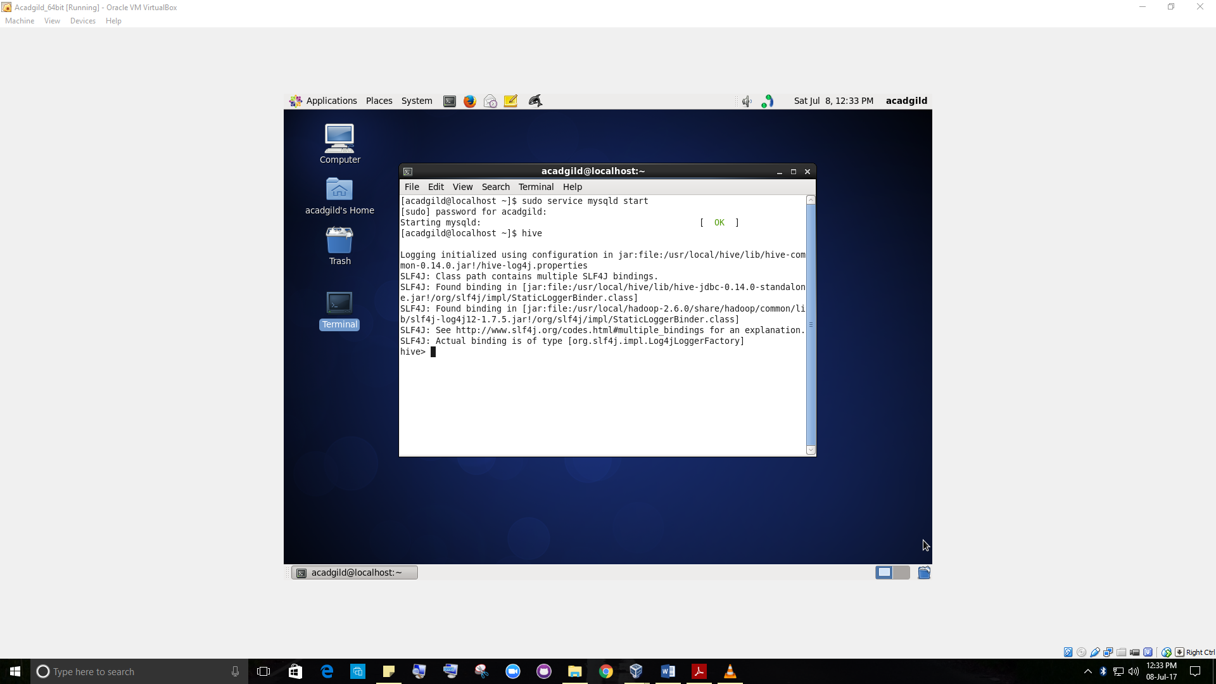

**Command 8:** start-hbase.sh (To start hbase)

